Mingus Union High School District
Tax Credit Information

Why give your money to Uncle Sam when you can help our students?
You get to CHOOSE where $400 of your tax dollars go!
Don’t allow the government to waste YOUR MONEY on programs you don’t like!

The Arizona tax law (ARS-43-1089.01) allows taxpayers a tax credit up to $400 if filing jointly or $200 per individual or head of household if they contribute to EXTRACURRICULAR ACTIVITIES in public schools.

What is an extracurricular activity?
Extracurricular activity means any optional, non-credit educational or recreational activity that supplements the education program of the school. Activities such as sports, visual and performing arts, special programs, field trips, clubs, outdoor education, gifted programs, career and technical education student organizations, or classroom enrichment programs can be funded with tax credit money.

Who is eligible?
This tax credit is available to all Arizona individual taxpayers regardless of whether or not they have children in school. An individual can contribute and receive a tax credit for any amount up to $200, or a couple filing jointly can contribute up to $400.

Do I have a choice of how much I can contribute or where the money goes?
You may indicate which school and which program you would like to support or you can designate your money to be given to the school(s) that have the greatest need. The amount of the tax credit you take does not have to be for the total allowable amount—you can make a difference in our schools with just $50, $75, or $100. In addition, the credit may be split between one or more schools; for example, $200 to an elementary school and $200 to a high school.

How can I take advantage of the tax credit?
Simply complete the detachable form and return or mail to the school. You can make contributions anytime throughout the year, however, checks or money orders must be received by December 31st and mailed tax credit request forms must be postmarked by December 31st.
----------------------------------------------------------------------------------------------------------------------------------------------------------------
I would like to support MUHS Welding students
and contribute to the Tax Credit Program
Enclosed is my contribution in the amount of $________ up to $400 joint/$200 individual tax returns

Name: _____________________________________________ Address:___________________________________

City: __________________________State:_______ Zip:_______________ Telephone: (_____ )________________

Signature: _________________________________________

Make checks payable to MUHS Welding Tax Credit Program
Drop off or mail to: 1801 East Fir Street, Cottonwood, AZ 86326
Clearly Mark on the outside of the envelope “TAX CREDIT”
A tax credit receipt will be mailed to you
Feel Free to contact Mingus Welding Instructor, Andrew Lamer at (928) 634-7531 for more information.

How Do Tax Credit Donations Help Mingus Welding Students?

Tax credit donations are used to pay registration costs to events like:
Attending SkillsUSA events. SkillsUSA is a National Career and Technical Student Organization, the mission of SkillsUSA is students, teachers, and industry working together to insure America has a skilled workforce. SkillsUSA trainings focus on professional development, team building, leadership, community service, and skill development.
- SkillsUSA Leadership Training Camp
- SkillsUSA Program of Work Conference
- SkillsUSA Washington Leadership Training Institute
- SkillsUSA On Ice
- SkillsUSA Regional Conference
- SkillsUSA State Conference
- SkillsUSA National Leadership and Skills Conference
Welding competitions and workshops.
- Welding Thunder
- Best in the West
- Cochise Community College invitational
- Tulsa Welding school senior welding competition
- Welders Without Borders Green Welding seminar
- American Welding Society meetings
- American Welding Society FabTech trade show
All the events listed have cost associated with them. Tax credits allow Mingus Welding students to attend the events with minimal cost covered by the students themselves.
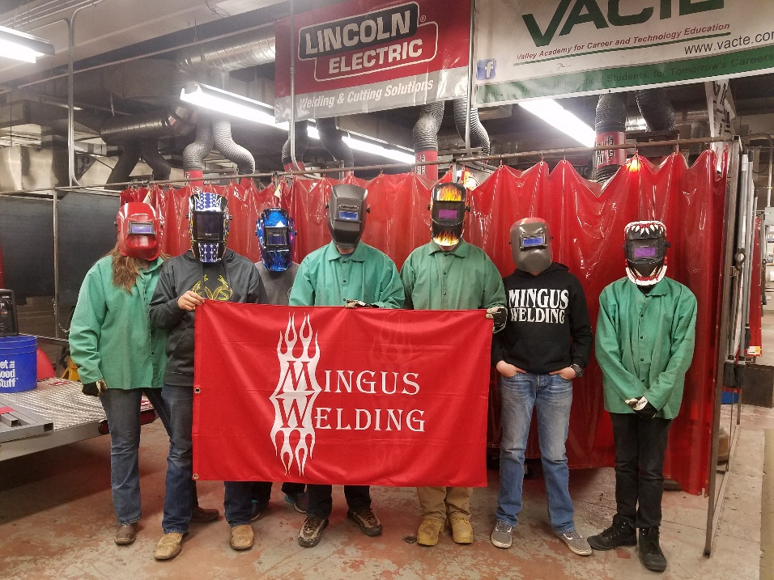
Thank You!

